The University of Azad Jammu and Kashmir, Muzaffarabad


Course: Digital Image Processing
Course Code: CS-2202
Roll No: 2024-SE-33
Lab: 3
Submitted To: Engr.Fahad Nisar
Submitted By: Momna imran
Date: 4 Nov, 2026
Task 1: Brightness Adjustment
Produce brighter and darker images using β = +40 and β = -40. Implement the +40 transformation using nested loops and verify that it matches the NumPy vectorized output exactly.
Input Test Pixels: [30, 80, 128, 180, 240]
- Brightness (+40): Raw: [70, 120, 168, 220, 280] -> Clipped & Final uint8: [70, 120, 168, 220, 255]
- Brightness (-40): Raw: [-10, 40, 88, 140, 200] -> Clipped & Final uint8: [0, 40, 88, 140, 200]
Detail Loss Explanation: Pixel values above 255 saturate (clip) to 255, causing high-intensity highlight details to flatten into pure white. Values below 0 clip to 0, losing shadow detail.
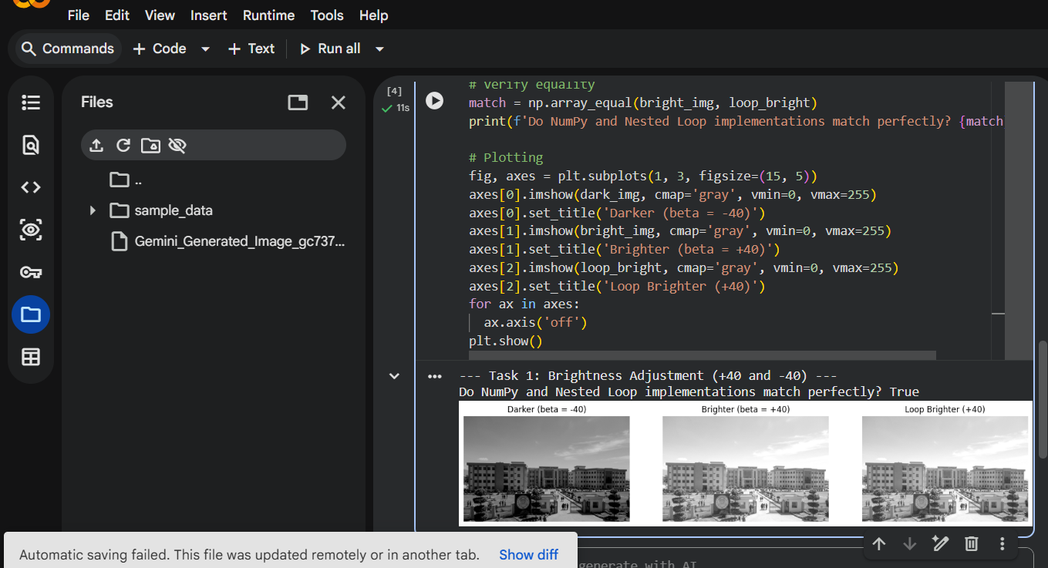
Task 2: Linear Contrast from Zero
Apply linear transformation s = α*r + β with α = 1.5 and β = 0. Compare brightness and highlight clipping against the original image.
Input Test Pixels: [30, 80, 128, 180, 240]
- r = 30: 1.5 * 30 = 45 -> 45
- r = 80: 1.5 * 80 = 120 -> 120
- r = 128: 1.5 * 128 = 192 -> 192
- r = 180: 1.5 * 180 = 270 -> Clipped to 255
- r = 240: 1.5 * 240 = 360 -> Clipped to 255
Dry Run Summary: Final Output: [45, 120, 192, 255, 255]. Pixels at 180 and 240 saturate to 255, resulting in lost highlight texture.
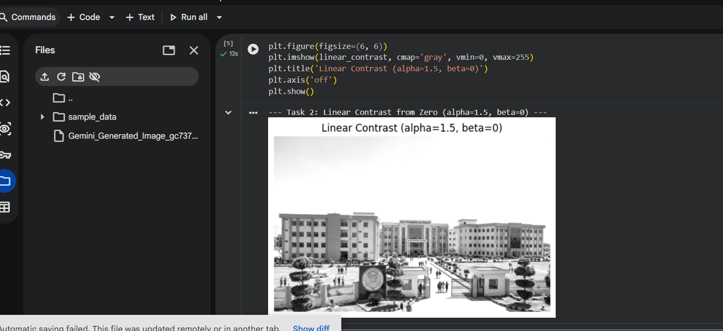
Task 3: Contrast Centered at Midpoint (128)
Apply s = (r - 128)*α + 128 with α = 1.5 and α = 0.5. Compare with linear contrast from zero.
Input Test Pixels: [30, 80, 128, 180, 240]
- Alpha = 1.5 Calculation: Output: [0, 56, 128, 206, 255] (Clipped at lower and upper bounds).
- Alpha = 0.5 Calculation: Output: [79, 104, 128, 154, 184] (Compressed dynamic range).
Midpoint Invariance: At r = 128, (128 - 128)*α + 128 = 128 for any α. The midpoint gray intensity remains completely invariant, anchoring the overall image brightness.
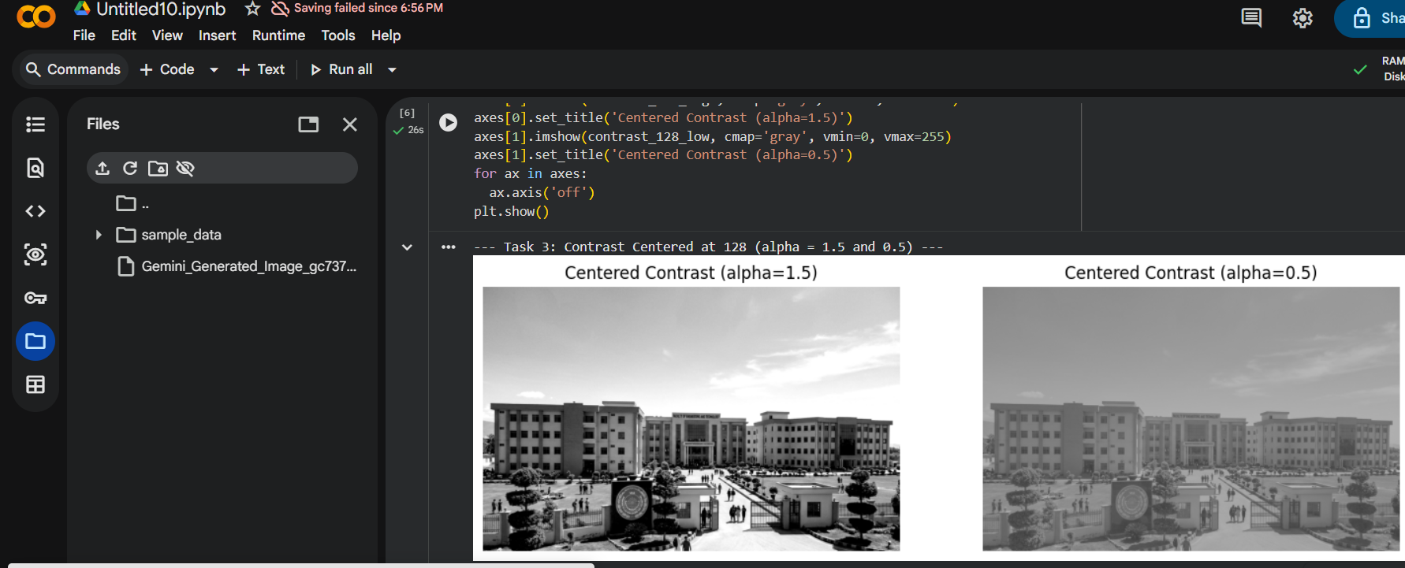
Task 4: Image Negative
Create the image negative using s = 255 - r. Re-apply the negative transformation to verify recovery of original values.
Dry Run: Input: [30, 80, 128, 180, 240] -> Negative: [225, 175, 127, 75, 15] -> Double Negative: [30, 80, 128, 180, 240] (Matches original).
Practical Application: Image negatives are highly effective for visualizing sparse dark details embedded in large light or gray regions, such as analyzing mammograms or micro-fractures in industrial non-destructive testing.
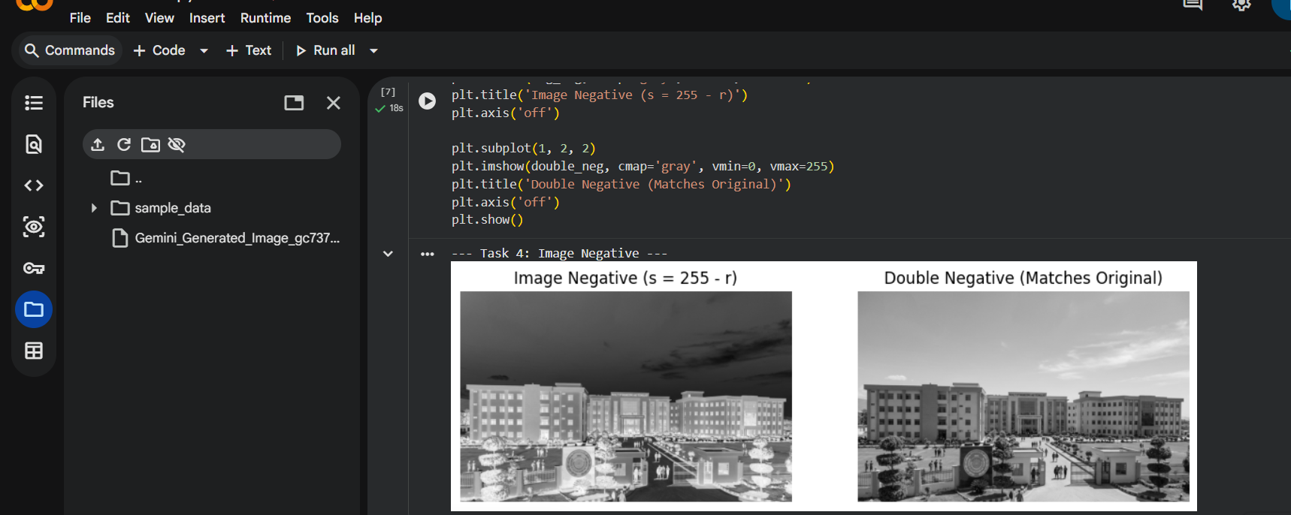
Task 5: Gamma Correction (Power-Law)
Apply s = 255 * (r / 255)^γ for γ = 0.5 and γ = 2.0. Truncate final outputs.
Input Test Pixels: [0, 64, 128, 192, 255]
- Gamma = 0.5: Normalized: [0, 0.251, 0.502, 0.753, 1.0] -> Output: [0, 128, 181, 221, 255]. Expands dark details.
- Gamma = 2.0: Normalized: [0, 0.251, 0.502, 0.753, 1.0] -> Output: [0, 16, 64, 144, 255]. Compresses dark details.
Boundary Behavior: 0 and 255 remain fixed because 0^γ = 0 and 1^γ = 1 for all positive γ.
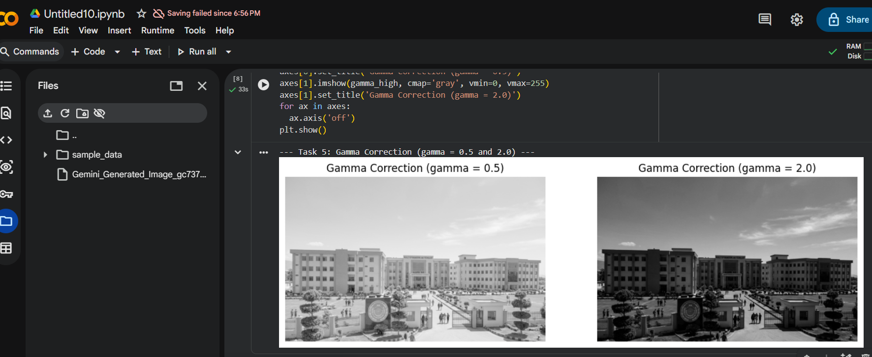
Task 6: Grayscale Histogram
Plot a labeled 256-bin histogram over 0–256 for the original image.
Dry Run Setup: Matrix A = [[0, 50, 50, 100], [100, 150, 200, 255]] (Total pixels = 8).
- Nonzero Frequencies & Probabilities: 0: 1 (P=1/8), 50: 2 (P=2/8), 100: 2 (P=2/8), 150: 1 (P=1/8), 200: 1 (P=1/8), 255: 1 (P=1/8).
Spatial Loss Explanation: A histogram collapses all spatial matrix coordinates into frequency counts. Therefore, completely different spatial arrangements of the exact same pixel intensities produce identical histograms.
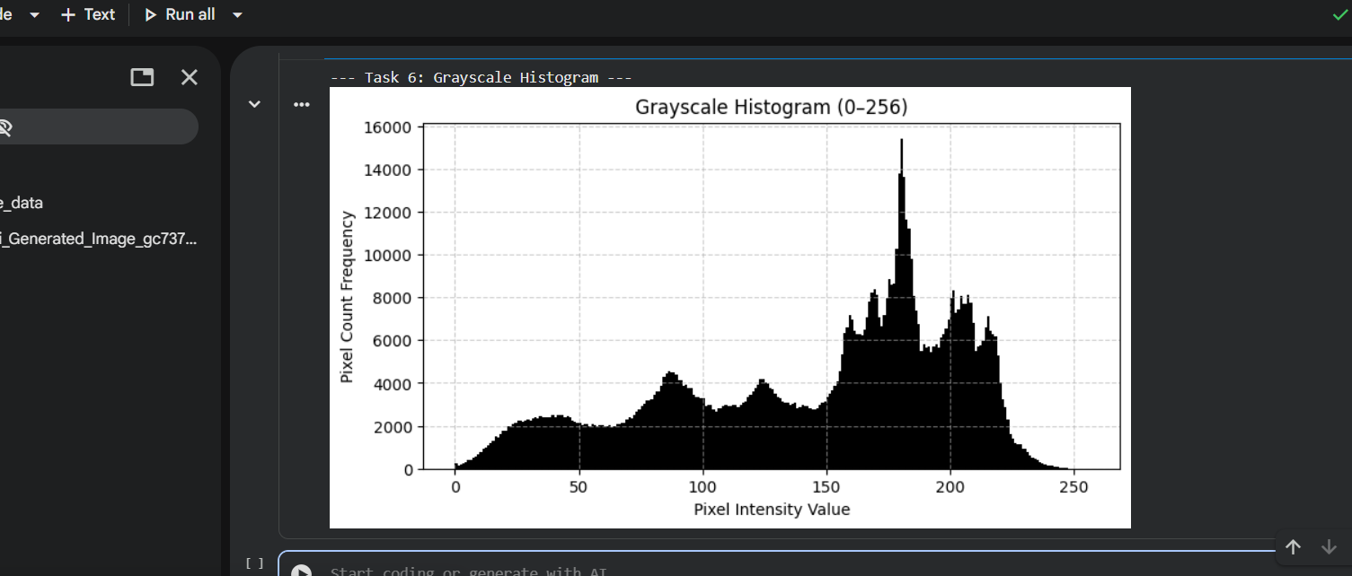
Task 7: Global Histogram Equalization
Apply cv2.equalizeHist to redistribute intensity levels globally across the full dynamic range.
Dry Run Setup: Pixels [50, 50, 100, 150]. Total pixels = 4.
- CDF Calculation: Counts: 50 (2), 100 (1), 150 (1). CDF: CDF(50)=2, CDF(100)=3, CDF(150)=4.
- Standard CDF Mapping: 255 * CDF Mapping: [128, 128, 191, 255]
- Normalized CDF Mapping: Formula: round(255 * (CDF - CDFmin) / (1 - CDFmin)) with CDFmin=2 -> Mapped Output: [0, 0, 128, 255]. Matches OpenCV behavior. 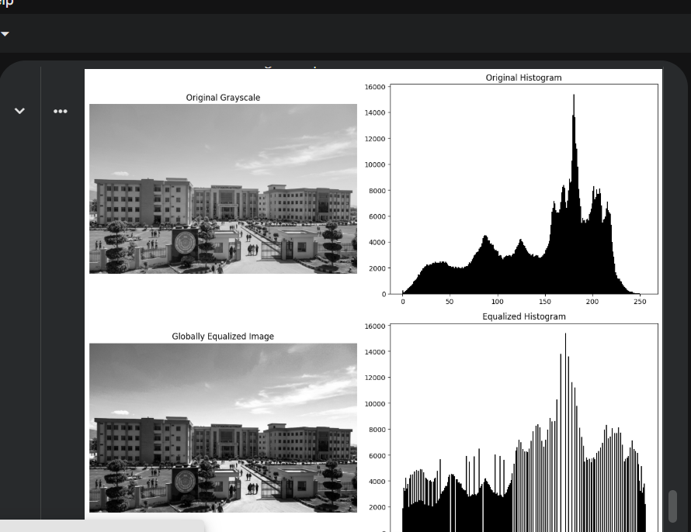
Task 8: Contrast Limited Adaptive Histogram Equalization (CLAHE)
Apply CLAHE with clipLimit = 2.0 and tileGridSize = (8, 8) to prevent over-amplification of noise in local regions.
Dry Run Setup: Four-bin histogram [6, 2, 0, 0], absolute cap = 4.
- Clipping: Clip bin 0 count from 6 to 4. Excess = 2.
- Redistribution: Redistribute excess (2 / 4 = 0.5 per bin) -> New Histogram: [4.5, 2.5, 0.5, 0.5].
- Tile Parameter Clarification: tileGridSize (8, 8) defines the number of contextual tile regions (8 rows by 8 columns) across the image, not the pixel dimensions of each tile.
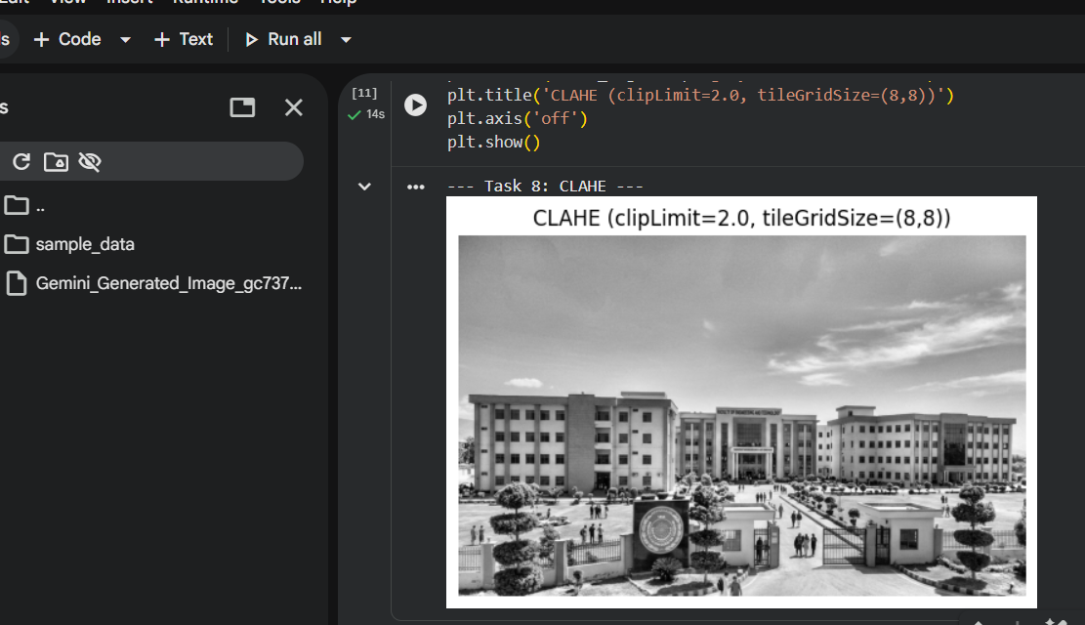
Task 9: Fixed Binary Thresholding
Apply cv2.THRESH_BINARY at T = 127.
Input Test Pixels: [0, 80, 127, 128, 180, 255]
- Threshold T = 127: Condition (r > 127) -> Output: [0, 0, 0, 255, 255, 255] (3 white pixels).
- Threshold T = 180: Condition (r > 180) -> Output: [0, 0, 0, 0, 0, 255] (1 white pixel).
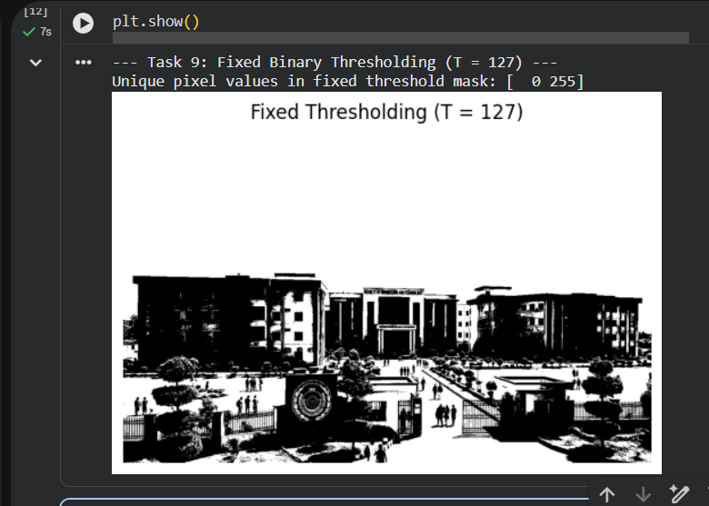
Task 10: Otsu Thresholding
Apply cv2.THRESH_OTSU to automatically determine the optimal global threshold by maximizing inter-class variance.
Input Pixels: [0, 1, 4, 5] without rescaling.
Dry Run Analysis: Evaluating candidate thresholds T in {0, 1, 2, 3, 4} yields maximum inter-class variance w0*w1*(mu0 - mu1)^2 at T = 2 (separating classes {0, 1} and {4, 5}). Optimal threshold selected: T = 2.\
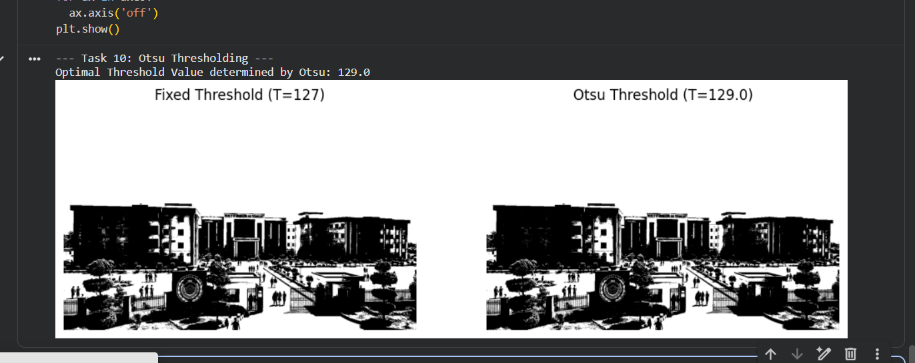

Task 11: Adaptive Gaussian Thresholding
Apply cv2.adaptiveThreshold with Gaussian weighting, blockSize = 11, and C = 2.
Dry Run Setup: Neighborhood [[100, 100, 100], [100, 120, 140], [140, 140, 140]] with Gaussian weight kernel [[1,2,1],[2,4,2],[1,2,1]] / 16.
- Weighted Mean & Threshold: Weighted Mean = 120. Threshold T = 120 - 2 = 118.
- Classification: Center pixel r = 120 > 118 -> Output = 255 (White). A pixel equal to T (118) is not > T, so it yields 0 (Black).


